Materials list for LoRa comms equipment:
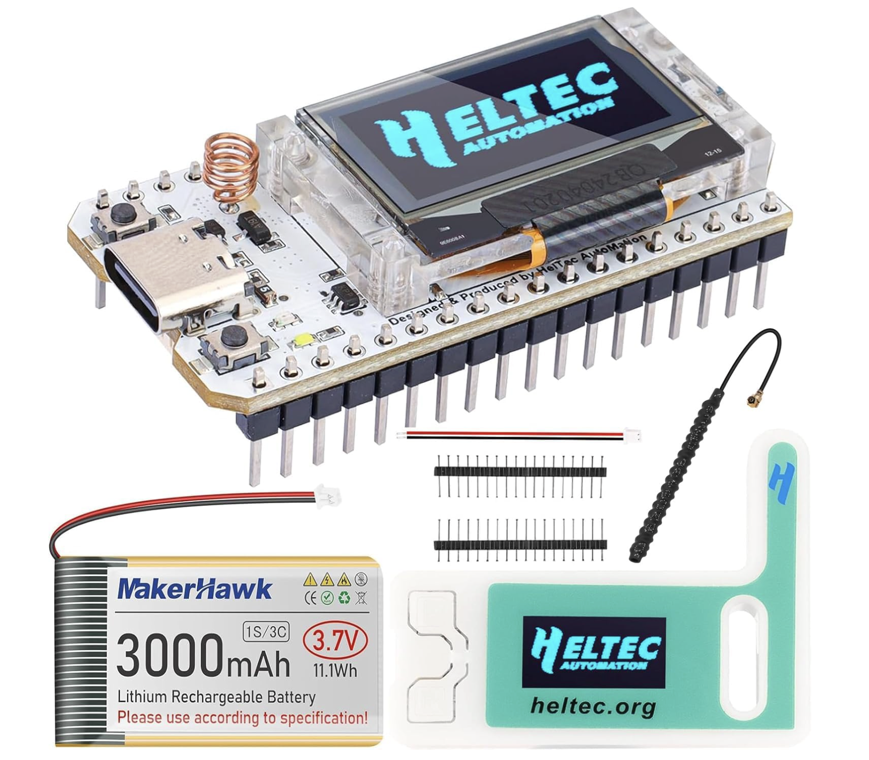
As in the above picture:
- Heltec V3 Development board MUST be 868MHz
- 1100 to 3000mAh Lithium-Ion battery
- Antenna – the one in the image above is the good antenna the little round cylinder type is not so good
- Case – the case above is good for a device you carry around with you – it fit's in a pocket and connects to your phone via to USB cable but cannot house a battery in the case and cannot connect to your phone by BLE as it would be unpowered. Case end is USB-C; phone end is whatever your phone is so you need ...
- the appropriate USB cable
- The case in the image below is better for a Heltec set up as a repeater...

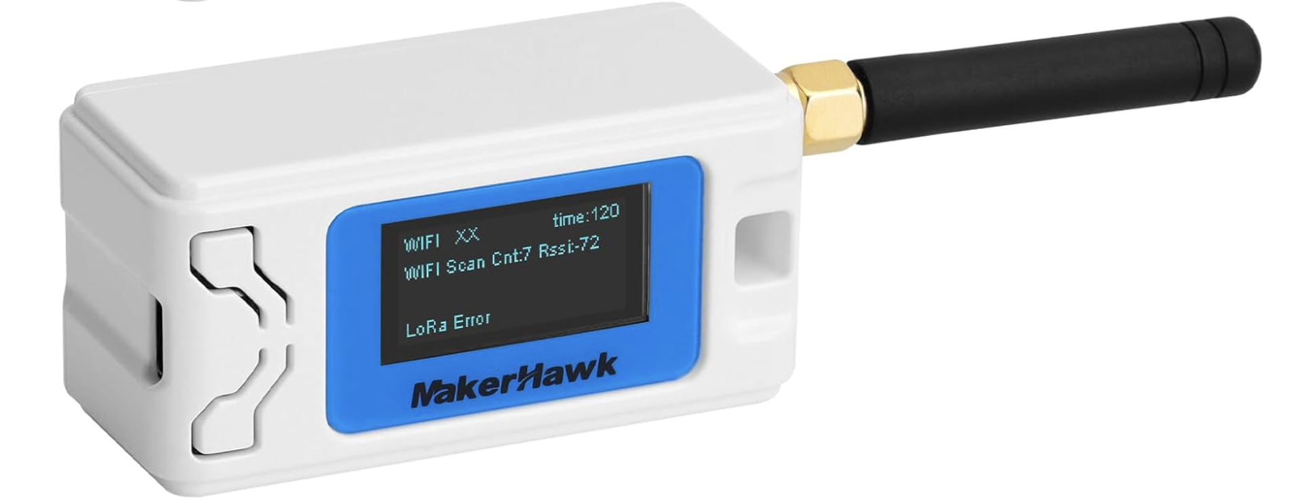
If you have your own IP-68 case as you mentioned then you don't need a case for your repeater units.

If you purchase this case then I'd get a better antenna especially as you would be intending to set up the device as a repeater so you want better reach of your signal. This antenna below is good – again make sure it's an 868MHz antenna. Most are 868 though they're sold out of China as being for 915MHz. The only way to tell for your is with an SWR meter.

Generic Rabbit-Labs 4dBm 868MHz 900MHz 915MHz Antenna SMA Male Connector Compatible with Meshtastic/LoRa
